Routers and Switches Theory

- Draw a labelled diagram of a typical home Wi-Fi router and a network switch, clearly marking at least 3 different ports (such as WAN, LAN, Console) and the location of status LEDs.

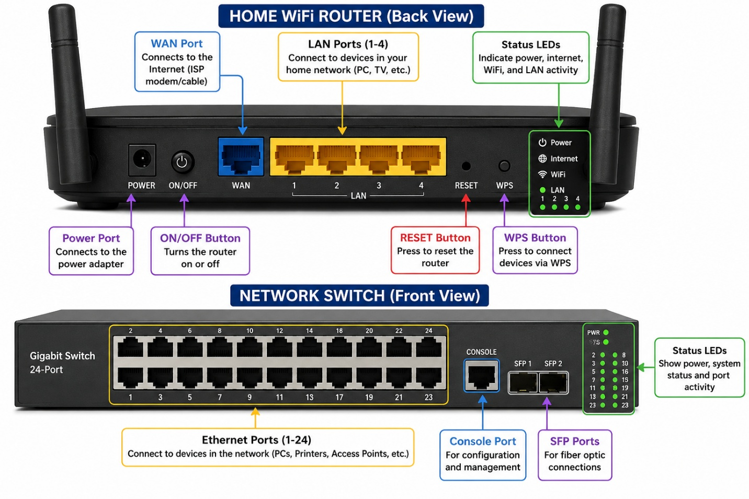
Fig 1. Home Router and Switch image

- List 3 key differences between routers and switches in terms of their main functions and how they handle network traffic. Hint: Think about how each device deals with IP addresses, MAC addresses, and the types of networks they connect.

Table 1: Router vs Switch

Router | Switch
Connects different networks (LAN to Internet). | Connects devices within the same network (LAN).
Uses IP addresses to send data between networks. | Uses MAC addresses to send data to the correct device.
Routes traffic between different networks and shares the Internet. | Forwards data only to the correct device inside the local network.

- Take a real or virtual image of a router and a switch (from your home, lab, or Google Images), and identify the following on each: Power port, at least 2 Ethernet ports, and any LED indicators. Annotate the image or describe their position and purpose.

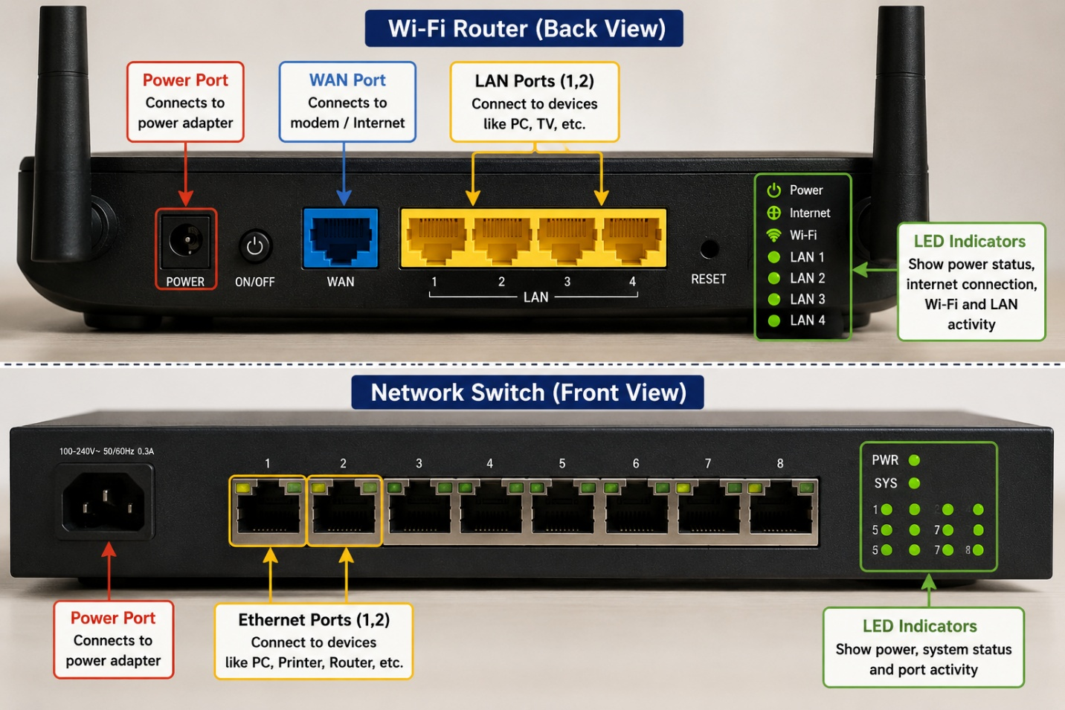
Fig 2. Router and Switch Port Identification

- Imagine you are setting up a small gaming café network for IPL streaming and multiplayer matches. Write a short scenario explaining which device (router or switch) you would connect first to the ISP line, and how you would connect 8 gaming PCs to the network. Justify your choices.

Scenario: Small Gaming Café Network
A small gaming café wants to stream IPL matches and allow 8 gaming PCs to play online multiplayer games. First, I would connect the router to the ISP (Internet Service Provider) line because the router provides internet access and assigns IP addresses to all devices. Then, I would connect a switch to one of the router's LAN ports. Finally, I would connect all 8 gaming PCs to the switch using Ethernet cables.
Justification:
- Router: Connects the café to the internet and manages IP addresses.
- Switch: Connects all 8 PCs together in the local network and provides fast communication between them.
- This setup gives stable internet, better network performance, and is easy to expand by adding more devices later.

